**CHAPTER 1**

**INTRODUCTION**

**1.1 INTRODUCTION:**

Real time clocks (RTC), as the name recommends are clock modules.[The DS1307 real time clock](http://www.edgefxkits.com/programmable-load-shedding-time-management-for-utility-department" \t "https://www.elprocus.com/rtc-ds1307/_blank) (RTC) IC is an 8 pin device using an I2C interface. The DS1307 is a low-power clock/calendar with 56 bytes of battery backup SRAM. The clock/calendar provides seconds, minutes, hours, day, date, month and year qualified data. The end date of each month is automatically adjusted, especially for months with less than 31 days.

They are available as integrated circuits (ICs) and supervise timing like a clock and also operate date like a calendar. The main advantage of RTC is that they have an arrangement of battery backup which keeps the clock/calendar running even if there is power failure. An exceptionally little current is required for keeping the RTC animated. We can find these RTCs in many applications like embedded systems and computer mother boards, etc. In this article we are going to see about one of the real time clock (RTC), i.e. DS1307.

### 1.2 Objective of the report

The project is based on the interfacing of Real Time Clock and Temperature sensor with micro controller and to display the current time,date and temperature of rooms on a large 7 segment display mounted on wall.Project will also cover the display segment multiplexing technique.

Here we are using the concept of Multiplexing, In this at a time we can activate only one block and remaining will be deactivated mode. We are controlling large seven segment display with small controllers. Each block requires minimum 8 pins, So total we are operating in 20 pins.

**1.3 BLOCK DIAGRAM**

**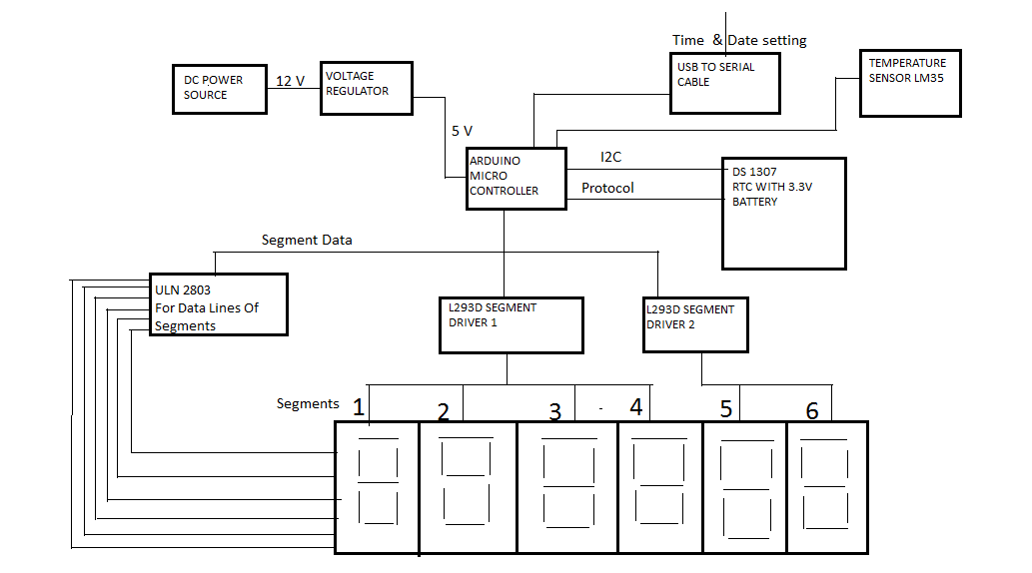**

**Fig 1.3.1 : Block Diagram of RTC Based Wall Mounting Digital Clock, Calendar and Temperature Display System**

**1.4 Micro Controller Aurdino uno(ATMEGA328P):** The Atmel pico Power ATmega328/P is a low-power CMOS 8-bit micro controller based on the AVR enhanced RISC architecture. By executing powerful instructions in a single clock cycle, the ATmega328/P achieves through puts close to 1MIPS per MHz. This empowers system designer to optimize the device for power consumption versus processing speed.

**Features:**

Family

• High Performance, Low Power Atmel®AVR® 8-Bit Micro controller Advanced RISC Architecture

– 131 Powerful Instructions

– Most Single Clock Cycle Execution

– 32 x 8 General Purpose Working Registers

– Fully Static Oper ation

– Up to 20 MIPS Throughput at 20MHz

– On-chip 2-cycle Multiplier

• High Endurance Non-volatile Memory Segments

– 32KBytes of In-System Self-Programmable Flash program Memory

– 1KBytes EEPROM – 2KBytes Internal SRAM

– Write/Erase Cycles: 10,000 Flash/100,000 EEPROM

– Data Retention: 20 years at 85°C/100 years at 25°C

– Optional Boot Code Section with Independent Lock Bits

• In-System Programming by On-chip Boot Program

• True Read-While-Write Operation

– Programming Lock for Software Security

• Atmel® QTouch® Library Support

– Capacitive Touch Buttons, Sliders and Wheels

– QTouch and QMatrix® Acquisition

– Up to 64 sense channels Atmel

• Peripheral Features

– Two 8-bit Timer/Counters with Separate Prescaler and Compare Mode

– One 16-bit Timer/Counter with Separate Prescaler, Compare Mode.

– Real Time Counter with Separate Oscillator

– Six PWM Channels

– 8-channel 10-bit ADC in TQFP and QFN/MLF package

• Temperature Measurement

– 6-channel 10-bit ADC in PDIP Package

• Temperature Measurement

– Two Master/Slave SPI Serial Interface

– One Programmable Serial USART

– One Byte-oriented 2-wire Serial Interface (Philips I2C compatible)

– Programmable Watchdog Timer with Separate On-chip Oscillator

– One On-chip Analog Comparator

– Interrupt and Wake-up on Pin Change

• Special Microcontroller Features

– Power-on Reset and Programmable Brown-out Detection

– Internal Calibrated Oscillator

– External and Internal Interrupt Sources

– Six Sleep Modes: Idle, ADC Noise Reduction, Power-save.

• I/O and Packages

– 23 Programmable I/O Lines

– 28-pin PDIP, 32-lead TQFP, 28-pad QFN/MLF and 32-pad QFN/MLF

• Operating Voltage : 1.8 - 5.5V

• Temperature Range: 40°C to 105°C

• Speed Grade:

0 - 4MHz @ 1.8 - 5.5V

0 - 10MHz @ 2.7 - 5.5V

0 - 20MHz @ 4.5 - 5.5V

• Power Consumption at 1MHz, 1.8V, 25°C

– Active Mode: 0.2mA

– Power-down Mode: 0.1μA

– Power-save Mode: 0.75μA (Including 32kHz RTC)

**ARDUINO UNO:**

The Arduino uno is a microcontroller, based on the ATmega328(data sheet). It has 14 digital input or output pins(of which 6 can be used as PWM outputs), 6 analog inputs, a 16 MHZ crystal oscillator, a USB connection, a power jack and reset button. It contains every thing needed to support the microcontroller.

**VOLTAGE REGULATOR:**

It is an electronic device that maintains the voltage of the power source with in the acceptable limits.

It is needed to keep voltages within the prescribed range that can be tolerated the electrical equipment using that voltage.

**DRIVER IC'S(L293D):**

Arduino controller consists of total 6 blocks but each L293D can accomodate 4 channels only so we are using 2 device drivers.

**IC DRIVER ULN 2803:**

ULN2803  is a High voltage, high current Transistor Array IC used especially with Microcontrollers where we need to drive high power loads. Thic IC consists of a eight NPN Darlington connected transistors with common Clamp diodes for switching the loads connected to the output. This IC is widely used to drive high loads such Lamps, relays, motors etc. It is usually rated at 50v/500mA. This article brings out the working of ULN2803 IC and how to use it in a circuit.

**1.5 Organization report:**

This thesis consists of six chapters. In first chapter it discuss about introduction,objective and block diagram of the project. In chapter two, it will discuss more on theory and literature reviews that have been done. Chapter three will discuss about the Hardware used this project. It will explain details such as the connection of the circuit and the device to complete the circuit. Chapter four will discuss software used in this project. Results will be presented in chapter five. Last but not least, chapter six will discuss the conclusion and recommendation that can be done for the future work.

**CONCLUSION**

From this chapter1,objective, introduction to RTC and seven segment display, block diagram and its description is mentioned.

**CHAPTER 2**

**LITERATURE SURVEY**

As per the introduction, the requirements for the project needed to be researched from various sources. The literature survey involved the detailed study of the various hardware and software components required. This chapter explains the need to include these components in the project and the market survey done for each.

**2.1 Graphical LCD**

Since the Touch Screen is transparent, there must be a LCD below it to display whatever path is drawn on the Touch Screen. In addition, the LCD must be a Graphical LCD so that individual pixels can be plotted on it according to the point touched on the Touch Screen. On surfing internet, it was found that there are three types of on-chip controllers for Graphical LCDs:

1. T6963
2. KS0108
3. SED

The Graphical LCD with controllers T6963 and SED were not available in the local market. So we went for KS0108. Cost being the important factor, a GLCD with minimum resolution was needed which is 128 pixel x 64 pixel. The cost of the original Samsung 128x64 GLCD is Rs.3000 and that of the Chinese version varied from Rs.550 to Rs.750. The Chinese version was bought for Rs.550 from “CeePee electronics” [2]. The details of working of this GLCD are explained in section 4.2.

**2.2 RF Module**

For communication between the two units- the Touch Screen unit and the vehicle, a wireless connection needed to be established. For this purpose we used ASK (Amplitude Shift Keying) RF modules working at 433MHz. The cost this module (transmitter and receiver) is Rs.450.

**2.3 Temperature Sensor**

To get the temperature of the region to be surveyed, temperature sensors are needed. After surveying a lot of temperature sensors, it was decided to use DS1820 digital temperature sensor from DALLAS. These sensors were bought from local market for Rs.70 each.

**2.4 Real Time Clock (RTC)**

Besides the actual survey results, the time of survey is equally important. So a Real Time Clock was implemented on the vehicle. There are a lot of RTC chips available in the market differing in the way it communicates with the microcontroller. After studying all possible types of RTC, the RTC chip DS1307 from DALLAS, Texas Instruments was selected. A free sample was ordered from MAXIM semiconductors for use.

**2.5 Micro Controller**

The main component controlling all the components listed above is the micro controller. Today there are innumerable micro controllers from different companies, with different features, in different versions and with different advantages over others. The main points that needed to be considered for micro controller selection are discussed in section 3.5.

ATmega16 and ATmega32 from Atme1 were finally selected for the Touch Screen unit and the vehicle respectively.

**2.6 Embedded ‘C’ Programming Software**

Writing such a huge code in assembly is tedious and hence a C compiler for the microcontroller was needed. This would ensure easy programming and handling of various device libraries. CodevisionAVR was chosen for this purpose. It is a high performance ANSI C compiler, Integrated Development IDE, Automatic Program Generator and In-System Programmer for the Atmel AVR family of microcontrollers.

**2.7 Simulation software**

A simulation software was needed considering the fact that the hardware need not be changed in accordance with the changes in the software. This flexibility was needed since it would require less time to design the hardware. The benefit is that the hardware design may be changed just as easily as the software design. Proteus VSM suite was chosen for the purpose. It offers the ability to co-simulate both high and low-level micro-controller code in the context of a mixed-mode SPICE circuit simulation.

The reason for selection of the particular hardware and software units listed above is explained in detail in the next chapter.

**2.8 ATMEGA 328P**

It has 14 digital input/output pins (of which 6 can be used as PWM outputs), 6 analog inputs, a 16 MHz crystal oscillator, a USB connection, a power jack, an ICSP header, and a reset button. It contains everything needed to support the microcontroller; simply connect it to a computeThe Arduino Uno is a microcontroller board based on the ATmega328 r with a USB cable or power it with a AC-to-DC adapter or battery to get started. The Uno differs from all preceding boards in that it does not use the FTDI USB-to-serial driver chip. Instead, it features the Atmega8U2 programmed as a USB-to-serial converter. "Uno" means one in Italian and is named to mark the upcoming release of Arduino 1.0. The Uno and version 1.0 will be the reference versions of Arduno, moving forward. The Uno is the latest in a series of USB Arduino boards, and the reference model for the Arduino platform; for a comparison with previous versions, see the index of Arduino boards.

**CHAPTER 3**

**HARDWARE DESCRIPTION**

**3.1 SEVEN SEGMENT DISPLAY :**

* In 7 segment LED display,8 LED’S are used out of which 7 LED’S are used for displaying alpha numeric characters and the 8th LED is used for displaying decimal point.
* A Power supply of 5 V and 20 mA current is enough to drive the 7 segment LED display. These displays are used in public telephones , Railway reservations and Customer electronics.
* It is available in 2 formats,given by Common Anode Configuaration,where all the anodes are shorted and other one is Common Cathode Configuaration where all the cathodes are shorted.

**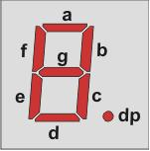**

**Fig 3.1.1 seven segment LED display**

**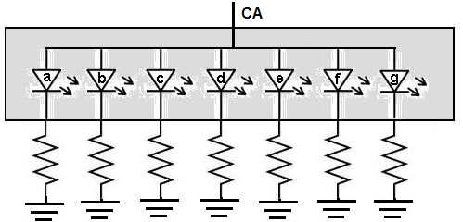**

**Fig 3.1.2 Common Anode LED Display**

**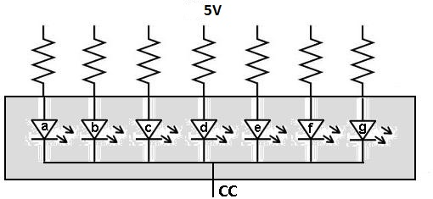**

**Fig 3.1.3 Common Cathode LED Display**

* A **seven-segment display** (**SSD**), or **seven-segment indicator**, is a form of electronic [display device](https://en.wikipedia.org/wiki/Display_device" \o "Display device) for displaying [decimal](https://en.wikipedia.org/wiki/Decimal" \o "Decimal)[numerals](https://en.wikipedia.org/wiki/Numeral_system" \o "Numeral system) that is an alternative to the more complex [dot matrix displays](https://en.wikipedia.org/wiki/Dot_matrix_display" \o "Dot matrix display).
* Seven-segment displays are widely used in [digital clocks](https://en.wikipedia.org/wiki/Digital_clock" \o "Digital clock), electronic meters, basic calculators, and other electronic devices that display numerical information.

**IMPLEMENTATION :**

Seven-segment displays may use a [liquid crystal display](https://en.wikipedia.org/wiki/Liquid_crystal_display" \o "Liquid crystal display) (LCD), a [light-emitting diode](https://en.wikipedia.org/wiki/Light-emitting_diode" \o "Light-emitting diode) (LED) for each segment, or other light-generating or controlling techniques such as cold [cathode](https://en.wikipedia.org/wiki/Cathode" \o "Cathode) gas discharge (Panaplex), [vacuum fluorescent](https://en.wikipedia.org/wiki/Vacuum_fluorescent_display" \o "Vacuum fluorescent display), [incandescent filaments](https://en.wikipedia.org/wiki/Incandescent_lamp" \o "Incandescent lamp) (Numitron), and others. For [gasoline](https://en.wikipedia.org/wiki/Gasoline" \o "Gasoline) price totems and other large signs, [vane displays](https://en.wikipedia.org/wiki/Vane_display" \o "Vane display) made up of electromagnetically flipped light-reflecting segments (or "vanes") are still commonly used. An alternative to the 7-segment display in the 1950s through the 1970s was the cold-cathode, neon-lamp-like [nixie tube](https://en.wikipedia.org/wiki/Nixie_tube" \o "Nixie tube). Starting in 1970, [RCA](https://en.wikipedia.org/wiki/RCA" \o "RCA) sold a display device known as the Numitron that used incandescent filaments arranged into a seven-segment display.

In a simple LED package, typically all of the [cathodes](https://en.wikipedia.org/wiki/Cathode" \o "Cathode) (negative terminals) or all of the [anodes](https://en.wikipedia.org/wiki/Anode" \o "Anode) (positive terminals) of the segment LEDs are connected and brought out to a common pin; this is referred to as a "common cathode" or "common anode" device. Hence a 7 segment plus decimal point package will only require nine pins, though commercial products typically contain more pins, and/or spaces where pins would go, in order to match standard [IC](https://en.wikipedia.org/wiki/Integrated_circuit" \o "Integrated circuit) sockets. Integrated displays also exist, with single or multiple digits. Some of these integrated displays incorporate their own internal [decoder](https://en.wikipedia.org/wiki/Binary_decoder" \o "Binary decoder), though most do not: each individual LED is brought out to a connecting pin as described.

### 3.2 Pin Description of DS1307:

### tL0034P001310386026

### Fig.no.3.2.1 DS 1307

***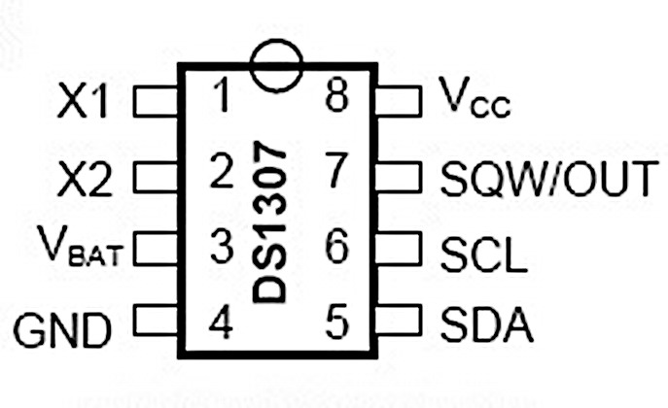***

**Fig.no.3.2.2 Pin diagram of DS 1307**

**Pin 1, 2:**Connections for standard 32.768 kHz quartz crystal. The internal oscillator circuitry is intended for operation with a crystal having a specified load capacitance of 12.5pF. X1 is the input to the oscillator and can alternatively be connected to an external 32.768 kHz oscillator. The output of the internal oscillator, X2 is drifted if an external oscillator is connected to X1.

**Pin 3**: Battery input for any standard 3V lithium cell or other energy source. Battery voltage should be between 2V and 3.5V for suitable operation. The nominal write protect trip point voltage at which access to the RTC and user RAM is denied is set by the internal circuitry as 1.25 x VBAT nominal. A lithium battery with 48mAhr or greater will backup the DS1307 for more than 10 years in the absence of power at 25ºC. UL recognized to ensure against reverse charging current when utilized as a part of conjunction with a lithium battery.

**Pin 4:**Ground.

**Pin 5:**Serial data input/output. The input/output for the I2C serial interface is the SDA, which is open drain and requires a pull up resistor, allowing a pull up voltage upto 5.5V. Regardless of the voltage on VCC.

**Pin 6:**Serial clock input. It is the I2C interface clock input and is used in data synchronization.

**Pin 7:**Square wave/output driver. When enabled, the SQWE bit set to 1, the SQW/OUT pin outputs one of four square-wave frequencies (1Hz, 4 kHz, 8 kHz, and 32 kHz). This is also open drain and requires an external pull-up resistor. It requires application of either Vcc or Vb at to operate SQW/OUT, with an allowable pull up voltage of 5.5V and can be left floating, if not used.

**Pin 8:** Primary power supply. When voltage is applied within normal limits, the device is fully accessible and data can be written and read. When a backup supply is connected to the device and VCC is below VTP, read and writes are inhibited. However at low voltages, the timekeeping function still functions.

**Features:**

* [Programmable square wave output signal](http://www.edgefxkits.com/portable-programmable-medication-reminder" \t "https://www.elprocus.com/rtc-ds1307/_blank)
* [Automatic power-fail detect and switch circuitry](http://www.edgefxkits.com/automatic-bell-system-for-institutions" \t "https://www.elprocus.com/rtc-ds1307/_blank)
* Consumes less than 500nA in battery backup mode with oscillator running
* Available in 8-pin DIP or SOIC
* Underwriters Laboratory (UL) recognized
* Real-time clock (RTC) counts seconds, minutes, hours, date of the month, month, day of the week, year with leap-year compensation valid up to 2100
* 56-byte non-volatile RAM for data storage
* Two-wire interface (I2C)

Using the DS1307 is primarily written to and read the registers of this chip. The memory contains all 64 DS1307 8-bit registers are addressed from 0 to 63 (from 00H to 3FH the hexadecimal system). The first eight registers are used for the clock register the remaining 56 vacant can be used as RAM contains temporary variable if desired. The first seven registers contain information about the time of the clock including: seconds, minutes, hours, secondary, date, month and year. The DS1307 include several components such as power circuits, oscillator circuits, logic controller and I2C interface circuit and the address pointer register (or RAM). Let’s see the working of DS1307.

**Working of DS1307:**

In the simple Circuit the two inputs X1 and X2 are connected to a 32.768 kHz crystal oscillator as the source for the chip. VBAT is connected to positive culture of a 3V battery chip. VCC power to the I2C interface is 5V and can be given using micro controllers. If the power supply VCC is not granted read and writes are inhibited.

START and STOP conditions are required when a device wants to establish communication with a device in the I2C network.

* By providing a device identification code and a register address, we can implement the START condition to access the device.
* The registers can be accessed in serial order until a STOP condition is implemented

The START condition and STOP condition when the DS1307 I2C communication with the microcontroller is shown in the figure below.

The DS1307 has the 2-wire bus connected to two I/O port pins of the DS5000: SCL – P1.0, SDA – P1.1. The VDD voltage is 5V, RP = 5KΩ and the DS5000 is by means of a 12-MHz crystal. The other secondary device could be any other device that recognizes the 2-wire protocol, such as the DS1621 Digital Thermometer and Thermostat. The interface with the D5000 was skilled using the DS5000T Kit hardware and software. These development kits allow the PC to be used as a dumb terminal using the DS5000’s serial ports to substitute a few words with the keyboard and monitor. Typical 2-wire bus arrangement, the following bus protocol has been defined during data exchange information; the data line must remain stable whenever the clock line is high. Changes in the data line while the clock line is high will be interpreted as control signals.Accordingly, the following bus conditions have been defined:

**Start data transfer**: A change in the state of the data line from high to low, while the clock line is high, defines a START condition.

**Stop data transfer**: A change in the state of the data line from low to high, while the clock line is high, defines the STOP condition.

**Data valid**: The state of the data line represents valid data when, after a START condition, the data line is stable for the duration of the high period of the clock signal. The data on the line must be changed during the low period of the clock signal. There is one clock pulse per bit of data.  
Each data transfer is initiated with a START condition and terminated with a STOP condition. The number of data bytes transferred between the START and the STOP conditions is not limited, and is determined by the master device. The information is transferred byte-wise and each receiver acknowledges with a ninth bit.

**3.3 HARDWARE COMPONENTS USED:**

**DC JACK:**

A DC connector (or **DC plug**, for one common type of connector) is an [electrical connector](https://en.wikipedia.org/wiki/Electrical_connector" \o "Electrical connector) for supplying [direct current](https://en.wikipedia.org/wiki/Direct_current" \o "Direct current) (DC) power.Compared to domestic [AC power plugs and sockets](https://en.wikipedia.org/wiki/AC_power_plugs_and_sockets" \o "AC power plugs and sockets), DC connectors have many more standard types that are not interchangeable. The dimensions and arrangement of DC connectors can be chosen to prevent accidental interconnection of incompatible sources and loads. Types vary from small coaxial connectors used to power portable electronic devices from [AC adapters](https://en.wikipedia.org/wiki/AC_adapter" \o "AC adapter), to connectors used for automotive accessories and for battery packs in portable equipment..

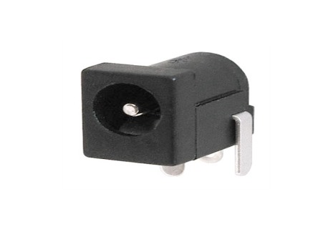

**Fig 3.3.1:DC jack**

**DC ADAPTOR**:

An AC adapter, AC/DC adapter, or AC/DC converter[[1]](https://en.wikipedia.org/wiki/AC_adapter" \l "cite_note-1) is a type of external [power supply](https://en.wikipedia.org/wiki/Power_supply" \o "Power supply), often enclosed in a case similar to an [AC plug](https://en.wikipedia.org/wiki/AC_power_plugs_and_sockets" \o "AC power plugs and sockets). Other common names include plug pack, plug-in adapter, adapter block, domestic mains adapter, line power adapter, wall wart, power brick, and power adapter. Adapters for battery-powered equipment may be described as chargers or rechargers (see also [battery charger](https://en.wikipedia.org/wiki/Battery_charger" \o "Battery charger)). AC adapters are used with electrical devices that require power but do not contain internal components to derive the required voltage and power from [mains power](https://en.wikipedia.org/wiki/Mains_electricity" \o "Mains electricity). The internal circuitry of an external power supply is very similar to the design that would be used for a built-in or internal supply.

External power supplies are used both with equipment with no other source of power and with [battery](https://en.wikipedia.org/wiki/Battery_(electricity)" \o "Battery (electricity))-powered equipment, where the supply, when plugged in, can sometimes charge the battery in addition to powering the equipment.

Use of an external power supply allows portability of equipment powered either by mains or battery without the added bulk of internal power components, and makes it unnecessary to produce equipment for use only with a specified power source; the same device can be powered from 120 VAC or 230 VAC mains, vehicle or aircraft battery by using a different adapters.

**ADVANTAGES OF DC ADAPTOR**

* **Safety** – External power adapters can free product designers from worrying about some safety issues. Much of this style of equipment uses only voltages low enough not to be a safety hazard internally, although the power supply must out of necessity use dangerous mains voltage. If an external power supply is used the equipment need not be designed with concern for hazardous voltages inside the enclosure. This is particularly relevant for equipment with lightweight cases which may break and expose internal electrical parts.
* **Heat reduction** – Heat reduces reliability and longevity of electronic components, and can cause sensitive circuits to become inaccurate or malfunction. A separate power supply removes a source of heat from the apparatus.
* **Electrical noise reduction** – Because radiated electrical noise falls off with the square of the distance, it is to the manufacturer's advantage to convert potentially noisy AC line power or automotive power to "clean", filtered DC in an external adapter, at a safe distance from noise-sensitive circuitry.
* **Weight and size reduction** – Removing power components and the mains connection plug from equipment powered by rechargeable batteries reduces the weight and size which must be carried.
* **Ease of replacement** – Power supplies are more prone to failure than other circuitry due to their exposure to power spikes and their internal generation of waste heat. External power supplies can be replaced quickly by a user without the need to have the powered device repaired.

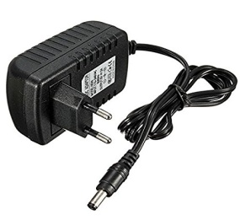

**Fig 3.3.2: DC Adaptor**

**LED:**

A light-emitting diode (**LED**) is a two-lead semiconductor light source. It is a p–n junction diode, which emits light when activated. When a suitable voltage is applied to the leads, electrons are able to recombine with electron holes within the device, releasing energy in the form of photons.

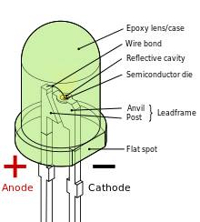 **Fig 3.3.3:LED**

LIGHT EMITTING DIODE commonly called LEDs, are real unsung heroes in the electronics world. They do dozens of different jobs and are found in all kinds of devices. Among other things they form numbers on digital clocks, transmit information from remote controls. Light up watches and tell you when your appliances are turned ON. Collected together, they can form images on a jumbo television screen or illuminate a traffic light. Basically, LEDs are just tiny light bulbs that fit easily into an electrical circuit. But unlike ordinary incandescent bulbs. They don’t have a filament that will burn out, and they don’t get especially hot. They are illuminated solely by the movement of electrons in semi-conductor material, and they last just as long as a standard transistor.Life span of an led surpasses the short life of an incandescent bulb by thousands of hours. Tiny led’ s are already replacing the tubes that light of HD TV’s to make dramatically thinner TV.In this we examine technology behind this these ubiquitous blinkers, illuminating some cool principles of electricity and light in the process.

**POTENTIOMETER:**

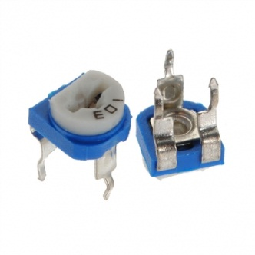

**Fig3.3.4 :Potentiometer**

Potentiometer also known as pot is generally used in circuits to provide variable resistance or variable voltage. The heart of the potentiometer is a resistive strip inside it through which one can adjust the amount of resistance/voltage to pass in a circuit through it. Potentiometers are commonly used in circuits for various purposes like to control volume in audio circuits, to regulate the speed of the motor in a fan, as light dimmer, etc..,

When we rotate the external shaft, the position of the brush varies accordingly. The resistance applied in a circuit depends on the position of the brush. The brush is designed so as to connect the resistive strip to the middle terminal via inner conductive circular metal plate which in turn is connected to the middle terminal of potentiometer at every instant.

**PUSH BUTTON:**

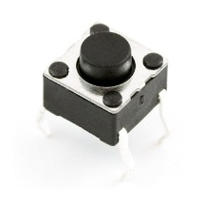

**Fig3.3.5 :push button**

Push Button Switches consist of a simple electric switch mechanism which controls some aspect of a machine or a process. Buttons are typically made out of hard material such as plastic or metal. The surface is usually shaped to accommodate the human finger or hand, so the electronic switch can be easily depressed or pushed. Also, most Push Button Switches are also known as biased switches. A biased switch, can be also considered what we call a "momentary switch" where the user will push-for "on" or push-for "off" type. This is also known as a push-to-make (SPST Momentary) or push-to break (SPST Momentary) mechanism.

Switches with the "push-to-make" (normally-open or NO) mechanism are a type of push button electrical switch that operates by the switch making contact with the electronic system when the button is pressed and breaks the current process when the button is released. An example of this is a keyboard button.

A "push-to-break" (or normally-closed or NC) electronic switch, on the other hand, breaks contact when the button is pressed and makes contact when it is released.

**100UF CAPACITOR:**

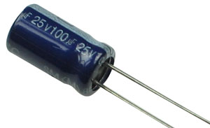

**Fig 3.3.6 :capacitor**

[Capacitor](http://www.electrical4u.com/what-is-capacitor-and-what-is-dielectric/) is a passive electronic component or device capable of storing charge with a certain voltage level across two conducting plates or surfaces, separated by an insulating material or dielectric substance.

As a capacitor is passive component, it does not generate energy. But it is able to store energy from an energy source like a battery or another charged capacitor. When a [battery](http://www.electrical4u.com/battery-history-and-working-principle-of-batteries/) (DC Source) is connected across a capacitor, one surface, named plate I gets positive end of the battery and another surface, named plate II gets negative end of the battery. When battery is connected, the full [voltage](http://www.electrical4u.com/voltage-or-electric-potential-difference/) of that battery is applied across that capacitor. At that situation, plate I is in positive potency with respect to the plate II. [Current](http://www.electrical4u.com/electric-current-and-theory-of-electricity/) from the battery tries to flow through this capacitor from its positive plate (plate I) to negative plate (plate II) but cannot flow at max value due to separation of these plates with an insulating material. Rather a very small current will flow through this insulating material (dielectric) from Positive to Negative plate depending upon the value of strength of this dielectric.

All electrolytic capacitors (e-caps) are polarized [capacitors](https://en.wikipedia.org/wiki/Capacitor" \o "Capacitor) whose [anode](https://en.wikipedia.org/wiki/Anode" \o "Anode) (+) is made of a particular metal on which an insulating oxide layer forms by [anodization](https://en.wikipedia.org/wiki/Anodization" \o "Anodization) , acting as the [dielectric](https://en.wikipedia.org/wiki/Dielectric" \o "Dielectric) of the electrolytic capacitor. A non-solid or solid electrolyte which covers the surface of the oxide layer in principle serves as the second electrode ([cathode](https://en.wikipedia.org/wiki/Cathode" \o "Cathode)) (-) of the capacitor. Due to their very thin dielectric oxide layer and enlarged anode surface, electrolytic capacitors have based on the volume—a much higher [capacitance](https://en.wikipedia.org/wiki/Capacitance" \o "Capacitance)-[voltage](https://en.wikipedia.org/wiki/Voltage" \o "Voltage) (CV) product compared to [ceramic capacitors](https://en.wikipedia.org/wiki/Ceramic_capacitor" \o "Ceramic capacitor) or [film capacitors](https://en.wikipedia.org/wiki/Film_capacitor" \o "Film capacitor), but a much smaller CV value than electrochemical [super capacitors](https://en.wikipedia.org/wiki/Supercapacitor" \o "Supercapacitor).

The large capacitance of electrolytic capacitors makes them particularly suitable for passing or bypassing low-frequency signals up to some mega-hertz and for storing large amounts of energy. They are widely used for decoupling or noise filtering in [power supplies](https://en.wikipedia.org/wiki/Power_supply" \o "Power supply) and DC link circuits for [variable-frequency drives](https://en.wikipedia.org/wiki/Variable-frequency_drive" \o "Variable-frequency drive), for coupling signals between amplifier stages, and storing energy as in a flash lamp.

**RESISTORS:**

A resistor is a passive two-terminal electrical component that implements electrical resistance as a circuit element. The current through a resistor is in direct proportion to the voltage across the resistor's terminals. Thus, the ratio of the voltage applied across a resistor's terminals to the intensity of current through the circuit is called resistance. This relation is represented by Ohm's law: where I is the current through the conductor in units of amperes, V is the potential difference measured across the conductor in units of volts, and R is the resistance of the conductor in units of ohms. More specifically, Ohm's law states that the R in this relation is constant, independent of the current. Resistors are common elements of electrical networks and electronic circuits and are ubiquitous in electronic equipment. Practical resistors can be made of various compounds and films, as well as resistance wire (wire made of a high-resistivity alloy, such as nickel-chrome). Resistors are also implemented within integrated circuits, particularly analog devices, and can also be integrated into hybrid and printed circuits.

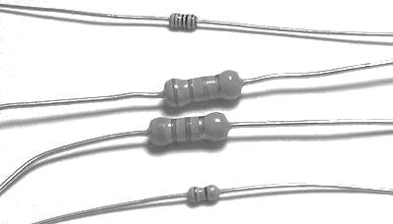

**Fig 3.3.7:resistor**

The electrical functionality of a resistor is specified by its resistance: common commercial resistors are manufactured over a range of more than nine orders of magnitude. When specifying that resistance in an electronic design, the required precision of the resistance may require attention to the manufacturing tolerance of the chosen resistor, according to its specific application. The temperature coefficient of the resistance may also be of concern in some precision applications. Practical resistors are also specified as having a maximum power rating which must exceed the anticipated power dissipation of that resistor in a particular circuit: this is mainly of concern in power electronics applications. Resistors with higher power ratings are physically larger and may require heat sinks. In a high-voltage circuit, attention must sometimes be paid to the rated maximum working voltage of the resistor.

**POWER BUTTON:**

Power button is used to turn ON/OFF of the circuit.

**DIODE:**

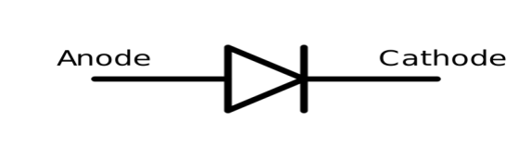 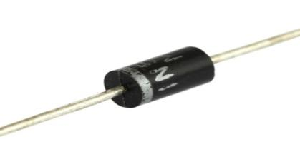

**Fig 3.3.8 :diode**

In electronics, a diode is a component that restricts the direction of movement of charge carriers. Essentially, it allows an electric current to flow in one direction, but blocks it in the opposite direction. Today the most common diodes are made from semiconductor materials such as silicon or germanium.

**POWER SUPPLY**:

A power supply is an internal hardware component that supplies components in a computer with power. The power supply converts a 110-115 or 220-230 volt alternating current (AC) into a steady low-voltage direct current (DC) uA.

**VOLTAGE REGULATOR** :

Voltage Regulator is one of the most important and commonly used electrical components. Voltage Regulators are responsible for maintaining a steady voltage across an Electronic system. **Voltage fluctuations** may result in undesirable effect on an electronic system, so to maintaining a steady constant voltage is necessary according to the voltage requirement of a system. Let us assume a condition when a simple light emitting diode can take a max of 3V to the max, what happens if the voltage input exceeds 3V ?, of course the diode will burn out. This is also common with all electronic components like, led’s, capacitors, diodes etc. The slightest increase in voltage may result in the failure of entire system by damaging the other components too. For avoiding Damage in such situations **voltage regulator** are used for regulated power supply.

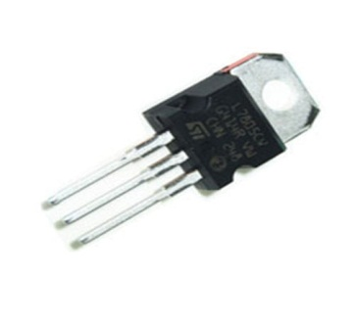

**Fig3.3.9 :voltage regulator**

The maximum value for input to the voltage regulator is 35V. It can provide a constant steady voltage flow of 5V for higher voltage input till the threshold limit of 35V. If the voltage is near to 7.5V then it does not produce any heat and hence no need for heat sink. If the voltage input is more, then excess electricity is liberated as heat from 7805.It regulates a steady output of 5V if the input voltage is in rage of 7.2V to 35V. Hence to avoid power loss try to maintain the input to 7.2V. In some circuitry voltage fluctuation is fatal (for e.g. Microcontroller), for such situation to ensure constant voltage **IC 7805 Voltage Regulator** is used.

**CONNECTING WIRES:**

Wire comes in solid core, stranded, or braided forms. Although usually circular in cross-section, wire can be made in square, hexagonal, flattened rectangular, or other cross-sections, either for decorative purposes, or for technical purposes such as high-efficiency [voice coils](https://en.wikipedia.org/wiki/Voice_coil" \o "Voice coil) in [loudspeakers](https://en.wikipedia.org/wiki/Loudspeaker" \o "Loudspeaker). Edge-wound [coil springs](https://en.wikipedia.org/wiki/Coil_spring" \o "Coil spring), such as the [Slinky](https://en.wikipedia.org/wiki/Slinky" \o "Slinky) toy, are made of special flattened wire.

**CRYSTAL OSCILLATOR:**

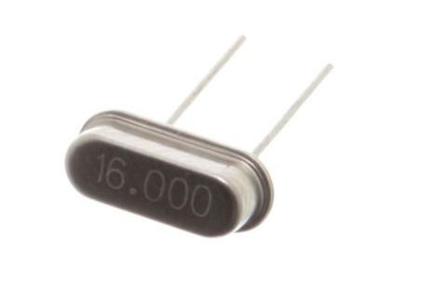 **Fig 3.3.10 16MHz oscillator**

An [electronic circuit](https://www.elprocus.com/electronic-circuits-for-engineering-students/" \t "_blank) or electronic device that is used to generate periodically oscillating electronic signal is called as an electronic oscillator. The electronic signal produced by an oscillator is typically a sine wave or square wave. An electronic oscillator converts the direct current signal into an alternating current signal. The radio and television transmitters are broad casted using the signals generated by oscillators. The electronic beep sounds and video game sounds are generated by the oscillator signals. These oscillators generate signals using the principle of oscillation. An electronic circuit that is used to generate an electrical signal of precise frequency by utilizing the vibrating crystal’s mechanical resonance made of [piezoelectric material](http://www.edgefx.in/piezoelectric-sensor-switch-working/" \t "_blank).

Crystal oscillator circuit works on the principle of the inverse piezoelectric effect, i.e., a mechanical deformation is produced by applying an electric field across certain materials. Thus, it utilizes the vibrating crystal’s mechanical resonance which is made of a piezoelectric material for generating an [electrical signal](http://www.edgefx.in/solar-charge-controller-circuit-using-microcontroller/" \t "_blank) of a specific frequency. These quartz crystal oscillators are highly stable, consists of good quality factor, they are small in size, and are very economical. Hence, quartz crystal oscillator circuits are superior compared to other resonators such as LC circuits, turning forks, and so on. Generally,16MHz crystal oscillator is used in [microprocessors and microcontrollers](http://www.edgefx.in/difference-between-microprocessor-and-microcontroller/" \t "_blank). In general, we know that, crystal oscillators are used in the microprocessors and microcontrollers for providing the clock signals. This crystal oscillator is used to generate clock pulses required for the synchronization of all the internal operations.

**BOOT LOADER:**

Boot loader primarily manages and executes the boot sequence of a computer system. A boot loader program is typically started after the computer or the BIOS have finished performing the initial power and hardware device checks and tests. It fetches the OS kernel from the hard disk or any specified boot device within the boot sequence, into the main memory. A boot loader is associated with only a single operating system. An operating system can also have multiple boot loader programs classified as primary and secondary boot loaders, where a secondary boot loader might be larger and more capable than the primary.

### RESET BUTTON:

Just like the original Nintendo, the Arduino has a reset button **(10)**. Pushing it will temporarily connect the reset pin to ground and restart any code that is loaded on the Arduino. This can be very useful if your code doesn’t repeat, but you want to test it multiple times. Unlike the original Nintendo however, blowing on the Arduino doesn’t usually fix any problems.

**3.4 PIN DIAGRAM OF ATMEGA328P :**

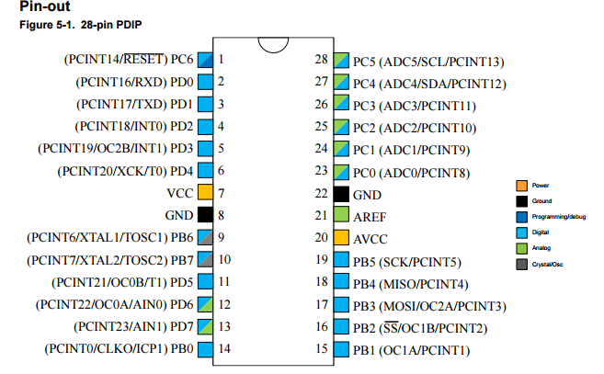 **Fig3.4.1 pin diagram of ATmega328p**

* Pin Descriptions:

VCC: Digital supply voltage.

* GND: Ground.

**Port A (PA7...PA0):**

Port A serves as the analog inputs to the A/D Converter. Port A also serves as an 8-bit bi-directional I/O port, if the A/D Converter is not used. Port pins can provide internal pull-up resistors (selected for each bit). The Port A output buffers have symmetrical drive characteristics with both high sink and source capability. When pins PA0 to PA7 are used as inputs and are externally pulled low, they will source current if the internal pull-up resistors are activated. The Port A pins are tri-stated when a reset condition becomes active, even if the clock is not running.

**Port B (PB7...PB0):**

Port B is an 8-bit bi-directional I/O port with internal pull-up resistors (selected for each bit). The Port B output buffers have symmetrical drive characteristics with both high sink and source capability. As inputs, Port B pins that are externally pulled low will source current if the pull-up resistors are activated. The Port B pins are tri-stated when a reset condition becomes active, even if the clock is not running. Port B also serves the functions of various special features of the ATmega32 as listed on page 57.

**Port C (PC7...PC0):**

Port C is an 8-bit bi-directional I/O port with internal pull-up resistors (selected for each bit). The Port C output buffers have symmetrical drive characteristics with both high sink and source capability. As inputs, Port C pins that are externally pulled low will source current if the pull-up resistors are activated. The Port C pins are tri-stated when a reset condition becomes active, even if the clock is not running. If the JTAG 28 interface is enabled, the pull-up resistors on pins PC5(TDI), PC3(TMS) and PC2(TCK) will be activated even if a reset occurs. The TD0 pin is tristated unless TAP states that shift out data are entered. Port C also serves the functions of the JTAG interface and other special features of ATmega.

**Port D (PD7...PD0):**

Port D is an 8-bit bi-directional I/O port with internal pull-up resistors (selected for each bit). The Port D output buffers have symmetrical drive characteristics with both high sink and source capability. As inputs, Port D pins that are externally pulled low will source current if the pull-up resistors are activated. The Port D pins are tri-stated when a reset condition becomes active, even if the clock is not running. Port D also serves the functions of various special features of ATmega.

**RESET:**

Reset Input. A low level on this pin for longer than the minimum pulse length will generate reset, even if the clock is not running. Shorter pulses are not guaranteed to generate a reset.

XTAL1: Input to the inverting Oscillator amplifier and input to the internal clock operating circuit.

XTAL2: Output from the inverting Oscillator amplifier.

AVCC: AVCC is the supply voltage pin for Port A and the A/D Converter. It should be externally connected to VCC, even if the ADC is not used. If the ADC is used, it should be connected to VCC through a low-pass filter.

AREF: AREF is the analog reference pin for the A/D Converter

The table below gives a description for each of pins, along with function.

|  |  |  |
| --- | --- | --- |
| **Pin Number** | **Description** | **Function** |
| 1 | PC6 | Reset |
| 2 | PD0 | Digital Pin (RX) |
| 3 | PD1 | Digital Pin (TX) |
| 4 | PD2 | Digital Pin |
| 5 | PD3 | Digital Pin (PWM) |
| 6 | PD4 | Digital Pin |
| 7 | Vcc | Positive Voltage (Power) |
| 8 | GND | Ground |
| 9 | XTAL 1 | Crystal Oscillator |
| 10 | XTAL 2 | Crystal Oscillator |
| 11 | PD5 | Digital Pin (PWM) |
| 12 | PD6 | Digital Pin (PWM) |
| 13 | PD7 | Digital Pin |
| 14 | PB0 | Digital Pin |
| 15 | PB1 | Digital Pin (PWM) |
| 16 | PB2 | Digital Pin (PWM) |
| 17 | PB3 | Digital Pin (PWM) |
| 18 | PB4 | Digital Pin |
| 19 | PB5 | Digital Pin |
| 20 | AVCC | Positive voltage for ADC (power) |
| 21 | AREF | Reference Voltage |
| 22 | GND | Ground |
| 23 | PC0 | Analog Input |
| 24 | PC1 | Analog Input |
| 25 | PC2 | Analog Input |
| 26 | PC3 | Analog Input |
| 27 | PC4 | Analog Input |
| 28 | PC5 | Analog Input |

**Table1:pin configuration**

**CONCLUSION:**

In this chapter components used in the project is mentioned and described, explanation of Arduino uno and its pin configuration is done.

**CHAPTER-4**

**SOFTWARE DESCRIPTION**

**4.1 Introduction:**

Arduino/Genuino Uno is a microcontroller board based on the ATmega328P ([datasheet](http://www.atmel.com/Images/doc8161.pdf" \t "_blank)). It has 14 digital input/output pins (of which 6 can be used as PWM outputs), 6 analog inputs, a 16 MHz quartz crystal, a USB connection, a power jack, an ICSP header and a reset button. It contains everything needed to support the microcontroller; simply connect it to a computer with a USB cable or power it with a AC-to-DC adapter or battery to get started.. You can tinker with your UNO without worring too much about doing something wrong, worst case scenario you can replace the chip for a few dollars and start over again.

"Uno" means one in Italian and was chosen to mark the release of Arduino Software (IDE) 1.0. The Uno board and version 1.0 of Arduino Software (IDE) were the reference versions of Arduino, now evolved to newer releases. The Uno board is the first in a series of USB Arduino boards, and the reference model for the Arduino platform; for an extensive list of current, past or outdated boards see the Arduino index of boards.

The Uno differs from all preceding boards in that it does not use the FTDI USB-to-serial driver chip. Instead, it features the Atmega16U2 (Atmega8U2 up to version R2) programmed as a USB-to-serial converter.

The ATmega328 has 32 KB (with 0.5 KB occupied by the bootloader). It also has 2 KB of SRAM and 1 KB of EEPROM (which can be read and written with the EEPROM library.

The Arduino/Genuino Uno board can be powered via the USB connection or with an external power supply. The power source is selected automatically.

External (non-USB) power can come either from an AC-to-DC adapter (wall-wart) or battery. The adapter can be connected by plugging a 2.1mm center-positive plug into the board's power jack. Leads from a battery can be inserted in the GND and Vin pin headers of the POWER connector.

The board can operate on an external supply from 6 to 20 volts. If supplied with less than 7V, however, the 5V pin may supply less than five volts and the board may become unstable. If using more than 12V, the voltage regulator may overheat and damage the board. The recommended range is 7 to 12 volts.

**4.2 ARDUINO UNO:**

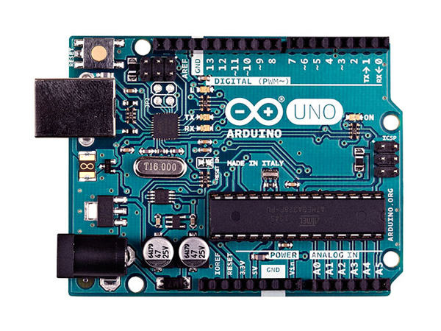

**Fig4.2.1 Arduino uno board**

**AUTOMATIC (SOFTWARE) RESET:**

Rather than requiring a physical press of the reset button before an upload, the Arduino/Genuino Uno board is designed in a way that allows it to be reset by software running on a connected computer. One of the hardware flow control lines (DTR) of the ATmega8U2/16U2 is connected to the reset line of the ATmega328 via a 100 nano farad capacitor. When this line is asserted (taken low), the reset line drops long enough to reset the chip. The Arduino Software (IDE) uses this capability to allow you to upload code by simply pressing the upload button in the interface toolbar. This means that the boot loader can have a shorter timeout, as the lowering of DTR can be well-coordinated with the start of the upload.

This setup has other implications. When the Uno is connected to either a computer running Mac OS X or Linux, it resets each time a connection is made to it from software (via USB). For the following half-second or so, the boot loader is running on the Uno. While it is programmed to ignore malformed data (i.e. anything besides an upload of new code), it will intercept the first few bytes of data sent to the board after a connection is opened. If a sketch running on the board receives one-time configuration or other data when it first starts, make sure that the software with which it communicates waits a second after opening the connection and before sending this data.

The Uno board contains a trace that can be cut to disable the auto-reset. The pads on either side of the trace can be soldered together to re-enable it. It's labeled "RESET-EN". You may also be able to disable the auto-reset by connecting a 110 ohm resistor from 5V to the reset line.

The Arduino Uno is a microcontroller board based on the ATmega328 . It has 14 digital input/output pins (of which 6 can be used as PWM outputs), 6 analog inputs, a 16 MHz ceramic resonator, a USB connection, a power jack, an ICSP header, and a reset button. It contains everything needed to support the microcontroller; simply connect it to a computer with a USB cable or power it with a AC-to-DC adapter or battery to get started.

The Arduino/Genuino Uno can be programmed with the ([Arduino Software](https://www.arduino.cc/en/Main/Software) (IDE)). Select "Arduino/Genuino Uno from the Tools - Board menu (according to the microcontroller on your board). For details, see the [reference](https://www.arduino.cc/en/Reference/HomePage) and [tutorials](https://www.arduino.cc/en/Tutorial/HomePage).

The ATmega328 on the Arduino/Genuino Uno comes pre programmed with a [boot loader](https://www.arduino.cc/en/Hacking/Bootloader?from=Tutorial.Bootloader) that allows you to upload new code to it without the use of an external hardware programmer. It communicates using the original STK500 protocol ([reference](http://www.atmel.com/Images/doc2525.pdf" \t "_blank), [C header files](http://www.atmel.com/dyn/resources/prod_documents/avr061.zip" \t "_blank)).You can also bypass the boot loader and program the microcontroller through the ICSP (In-Circuit Serial Programming) header using [Arduino ISP](https://www.arduino.cc/en/Main/ArduinoISP) or similar; see [these instructions](https://www.arduino.cc/en/Hacking/Programmer) for details.

The ATmega16U2 (or 8U2 in the rev1 and rev2 boards) firmware source code is available in the Arduino repository. The ATmega16U2/8U2 is loaded with a DFU bootloader, which can be activated by:

* On Rev1 boards: connecting the solder jumper on the back of the board (near the map of Italy) and then reseing the 8U2.
* On Rev2 or later boards: there is a resistor that pulling the 8U2/16U2 HWB line to ground, making it easier to put into DFU mode.

You can then use [Atmel's FLIP software](http://www.atmel.com/products/microcontrollers/default.aspx" \t "_blank) (Windows) or the [DFU programmer](http://dfu-programmer.github.io/" \t "_blank) (Mac OS X and Linux) to load a new firmware. Or you can use the ISP header with an external programmer (overwriting the DFU boot loader). See [this user-contributed tutorial](http://forum.arduino.cc/index.php/topic,111.0.html) for more information.

**Arduino :**

Arduino is an open-source electronics platform based on easy-to-use hardware and software. Arduino boards are able to read inputs - light on a sensor, a finger on a button, or a Twitter message - and turn it into an output - activating a motor, turning on an LED, publishing something online. You can tell your board what to do by sending a set of instructions to the microcontroller on the board. To do so you use the Arduino programming language (based on Wiring), and the Arduino Software (IDE), based on Processing. Over the years Arduino has been the brain of thousands of projects, from everyday objects to complex scientific instruments.

A worldwide community of makers - students, hobbyists, artists, programmers, and professionals - has gathered around this open-source platform, their contributions have added up to an incredible amount of accessible knowledge that can be of great help to novices and experts alike. Arduino was born at the Ivrea Interaction Design Institute as an easy tool for fast prototyping, aimed at students without a background in electronics and programming. As soon as it reached a wider community, the Arduino board started changing to adapt to new needs and challenges, differentiating its offer from simple 8-bit boards to products for IoT applications, wearable, 3D printing, and embedded environments. All Arduino boards are completely open-source, empowering users to build them independently and eventually adapt them to their particular needs. The software, too, is open-source, and it is growing through the contributions of users worldwide.

**Why Arduino :**

Thanks to its simple and accessible user experience, Arduino has been used in thousands of different projects and applications. The Arduino software is easy-to-use for beginners, yet flexible enough for advanced users. It runs on Mac, Windows, and Linux. Teachers and students use it to build low cost scientific instruments, to prove chemistry and physics principles, or to get started with programming and robotics. Designers and architects build interactive prototypes, musicians and artists use it for installations and to experiment with new musical instruments. Makers, of course, use it to build many of the projects exhibited at the Maker Faire, for example. Arduino is a key tool to learn new things. Anyone - children, hobbyists, artists, programmers - can start tinkering just following the step by step instructions of a kit, or sharing ideas online with other members of the Arduino community. There are many other microcontrollers and microcontroller platforms available for physical computing. Parallax Basic Stamp, Netmedia's BX-24, Phidgets, MIT's Handyboard, and many others offer similar functionality. All of these tools take the messy details of microcontroller programming and wrap it up in an easy-to-use package.

Arduino also simplifies the process of working with microcontrollers, but it offers some advantage for teachers, students, and interested amateurs over other systems:

**Inexpensive** - Arduino boards are relatively inexpensive compared to other microcontroller platforms. The least expensive version of the Arduino module can be assembled by hand, and even the pre-assembled Arduino modules cost less than $50

**Cross-platform** - The Arduino Software (IDE) runs on Windows, Macintosh OSX, and Linux operating systems. Most microcontroller systems are limited to Windows.

**Simple, clear programming environment** - The Arduino Software (IDE) is easy-to-use for beginners, yet flexible enough for advanced users to take advantage of as well. For teachers, it's conveniently based on the Processing programming environment, so students learning to program in that environment will be familiar with how the Arduino IDE works.

**Open source and extensible software** - The Arduino software is published as open source tools, available for extension by experienced programmers. The language can be expanded through C++ libraries, and people wanting to understand the technical details can make the leap from Arduino to the AVR C programming language on which it's based. Similarly, you can add AVR-C code directly into your Arduino programs if you want to.

**Open source and extensible hardware** - The plans of the Arduino boards are published under a Creative Commons license, so experienced circuit designers can make their own version of the module, extending it and improving it. Even relatively inexperienced users can build the breadboard version of the module in order to understand how it works and save money.

**Arduino Boards**

Arduino board is an open-source platform used to make electronics projects. It consists of both a microcontroller and a part of the software or Integrated Development Environment (IDE) that runs on your PC, used to write & upload computer code to the physical board.The platform of an Arduino has become very famous with designers or students just starting out with electronics, and for an excellent cause.

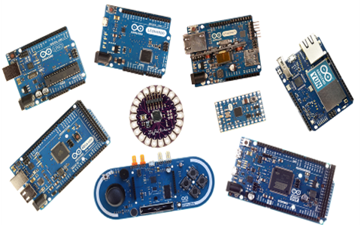

**Fig 4.2.2:Types of arduino Boards**

Unlike most earlier programmable circuit boards, the Arduino does not require a separate part of hardware in order to program a new code onto the board you can just use a USB cable. As well, the Arduino IDE uses a basic version of C++, making it simpler to learn the program. At last, Arduino board offers a typical form factor that breaks out the functions of the microcontroller into a more available package.

**4.3 Types of Arduino Board :**

* Arduino Uno (R3)
* LilyPad Arduino
* Arduino Mini
* Arduino Mega (R3)
* Arduino Leonardo
* Arduino Nano
* Arduino Yun
* Arduino Esplora
* Arduino Fio
* Arduino Pro

**Ardunio Uno :**

The most common version of Arduino is the Arduino Uno. This board is what most people are talking about when they refer to an Arduino. The Uno is one of the more popular boards in the Arduino family and a great choice for beginners. There are different revisions of Arduino Uno, below detail is the most recent revision (Rev3 or R3).

The Arduino Uno is a microcontroller board based on the ATmega328. It has 14 digital input/output pins (of which 6 can be used as PWM outputs), 6 analog inputs, a 16 MHz ceramic resonator, a USB connection, a power jack, an ICSP header, and a reset button. It contains everything needed to support the microcontroller; simply connect it to a computer with a USB cable or power it with an AC-to-DC adapter or battery to get started.

Microcontroller   : ATmega328

Operating Voltage     : 5V

Input Voltage (recommended)            : 7-12V

Input Voltage (limits)                           : 6-20V

Digital I/O Pins                                  : 14 (of which 6 provide PWM

Analog Input Pins                                : 6

DC Current per I/O Pin                         : 40 mA

DC Current for 3.3V Pin                       : 50 mA

Flash Memory                               : 32 KB (ATmega328) of which 0.5 KB used by  bootloader

SRAM                                            : 2 KB (ATmega328)

EEPROM                                         : 1 KB (ATmega328)

Clock Speed                                      : 16 MHz

Length                                            : 68.6 mm

Width                                             : 53.4 mm

**USB Plug & External Power Supply Plug :**

Every Arduino board needs a way to be connected to a power source. The Arduino Uno can be powered from a USB cable coming from your computer or a wall power supply that is terminated in a barrel jack. The power source is selected automatically. The USB connection is also how you will load code onto your Arduino board. Please on my other post on how to program with Arduino can be found in Installing and Programming Arduino.

NOTE: The board can operate on an external supply of 6 to 20 volts. If supplied with less than 7V, however, the 5V pin may supply less than five volts and the board may be unstable.If using more than 12V, the voltage regulator may overheat and damage the board. The recommended range is 7 to 12 volts

**Voltage Regulator :**

The voltage regulator is not actually something you can (or should) interact with on the Arduino. But it is potentially useful to know that it is there and what it’s for. The voltage regulator does exactly what it says – it controls the amount of voltage that is let into the Arduino board. Think of it as a kind of gatekeeper; it will turn away an extra voltage that might harm the circuit. Of course,it has its limits, so don’t hook up your Arduino to anything greater than 20 volts.

**Power Pins :**

Voltage In Pin – The input voltage to the Arduino board when it’s using an external power source(as opposed to 5 volts from the USB connection or other regulated power source). You can supply voltage through this pin, or, if supplying voltage via the power jack, access it through this pin.

5V Pin – This pin outputs a regulated 5V from the regulator on the board. The board can be supplied with power either from the DC power jack (7 – 12V), the USB connector (5V), or the VIN pin of the board (7-12V). Supplying voltage via the 5V or 3.3V pins bypasses the regulator, and can damage your board. It’s not recommended.3.3V Pin – A 3.3 volt supply generated by the on-board regulator. Maximum current draw is 50 mA.

**Ground Pins :**

There are several GND pins on the Arduino, any of which can be used to ground your circuit.

**IOREF Pin** :

This pin on the Arduino board provides the voltage reference with which the microcontroller operates. A properly configured shield can read the IOREF pin voltage and select the appropriate power source or enable voltage translators on the outputs for working with the 5V or 3.3V.

**Input and Output Pins :**

Each of the 14 digital pins on the Uno can be used as an input or output. They operate at 5 volts. These pins can be used for both digital input (like telling if a button is pushed) and digital output (like powering an LED). Each pin can provide or receive a maximum of 40 mA and has an internal pull-up resistor (disconnected by default) of 20-5k Ohms. In addition, some pins have specialized functions.

**Serial Out (TX) & Serial In (RX) :**

Used to receive (RX) and transmit (TX) TTL serial data. These pins are connected to the corresponding pins of the ATmega8U2 USB-to-TTL Serial chip.

**External Interrupts** :

Pins 2 and 3 can be configured to trigger an interrupt on a low value, a rising or falling edge, or a change in value.

PWM– You may have noticed the tilde (~) next to some of the digital pins (3, 5, 6, 9, 10, and 11). These pins act as normal digital pins, but can also be used for something called Pulse-Width Modulation (PWM).  Think of these pins as being able to simulate analog output (like fading an LED in and out).

**SPI :**

Pins 10 (SS), 11 (MOSI), 12 (MISO), 13 (SCK). SPI stands for Serial Peripheral Interface. These pins support SPI communication using the SPI library.

**Analog Input Pins** :

Labeled A0 through A5, each of which provide 10 bits of resolution (i.e. 1024 different values). These pins can read the signal from an analog sensor (like a temperature sensor) and convert it into a digital value that we can read. By default they measure from ground to 5 volts, though is it possible to change the upper end of their range using the AREF Pin(Stands for Analog Reference. Most of the time you can leave this pin alone). Additionally, some pins have specialized functionality:

**TWI** :

Pins A4 or SDA pin and A5 or SCL pin. Support TWI communication using the Wire library.

**Reset Pin :**

Bring this line LOW to reset the microcontroller.Typically used to add a reset button to shields which block the one on the board.

**LED Indicator :**

Power LED Indicator – Just beneath and to the right of the word “UNO” on your circuit board, there’s a tiny LED next to the word ‘ON’. This LED should light up whenever you plug your Arduino into a power source. If this light doesn’t turn on, there’s a good chance something is wrong. Time to re-check your circuit!

**On-Board LED** :

There is a built-in LED connected to digital pin 13. When the pin is HIGH value, the LED is on, when the pin is LOW, it’s off. This useful to quickly check if the board has no problem as some boards has a pre-loaded simple blinking LED program in it.

**TX & RX LEDs** :

These LEDs will give us some nice visual indications whenever our Arduino is receiving or transmitting data (like when we’re loading a new program ontotheboard).

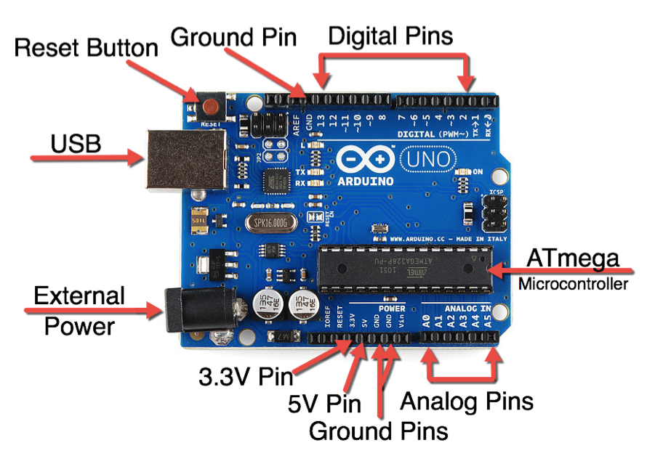

**Fig 4.3.1: Pin description of Arduino Uno**

**ATMega328:**

The Atmel 8-bit AVR RISC-based microcontroller combines 32 kB ISP flash memory with read-while-write capabilities, 1 kB EEPROM, 2 kB SRAM, 23 general purpose I/O lines, 32 general purpose working registers, three flexible timer/counters with compare modes, internal and external interrupts, serial programmable USART, a byte-oriented 2-wire serial interface, SPI serial port, 6-channel 10-bit A/D converter (8-channels in TQFP and QFN/MLF packages), programmable watchdog timer with internal oscillator, and five software selectable power saving modes. The device operates between 1.8-5.5 volts. The device achieves throughput approaching 1 MIPS per MHz.

|  |  |
| --- | --- |
| **Parameter** | **Value** |
| CPU type | 8-bit AVR |
| Performance | 20 [MIPS](https://en.wikipedia.org/wiki/Instructions_per_second" \o "Instructions per second) at 20 MHz[[2]](https://en.wikipedia.org/wiki/ATmega328" \l "cite_note-m8271ds-2) |
| [Flash memory](https://en.wikipedia.org/wiki/Flash_memory" \o "Flash memory) | 32 kB |
| [SRAM](https://en.wikipedia.org/wiki/Static_random-access_memory" \o "Static random-access memory) | 2 kB |
| [EEPROM](https://en.wikipedia.org/wiki/EEPROM" \o "EEPROM) | 1 kB |
| Pin count | 28-pin [PDIP](https://en.wikipedia.org/wiki/Dual_in-line_package" \o "Dual in-line package), [MLF](https://en.wikipedia.org/wiki/Quad_Flat_No-leads_package" \l "Variants" \o "Quad Flat No-leads package), 32-pin [TQFP](https://en.wikipedia.org/wiki/Quad_Flat_Package" \o "Quad Flat Package), MLF[[2]](https://en.wikipedia.org/wiki/ATmega328" \l "cite_note-m8271ds-2) |
| Maximum operating frequency | 20 MHz |
| Number of touch channels | 16 |
| Maximum I/O pins | 26 |
| External interrupts | 24 |
| [USB](https://en.wikipedia.org/wiki/USB" \o "USB) Interface | No |

**Table 2: Keyparameters of ATmega328**

An ATmega328 in DIP package, pre-loaded with the Arduino Optiboot (Uno 16MHz) Bootloader. This will allow you to use Arduino code in your custom embedded project without having to use an actual Arduino board. To get this chip working with Arduino IDE, you will need an external 16MHz crystal or resonator, a 5V supply, and a serial connection. If you are not comfortable doing this, we recommend purchasing the Arduino Uno board that has all of these built into the board. Atmel’s ATMega328 8-Bit Processor in 28 pin DIP package. It’s like the ATmega168, with double the flash space. 32K of program space. 23 I/O lines, 6 of which are channels for the 10-bit ADC. Runs up to 20MHz with external crystal. Package can be programmed in circuit. 1.8V to 5V operating voltage!

**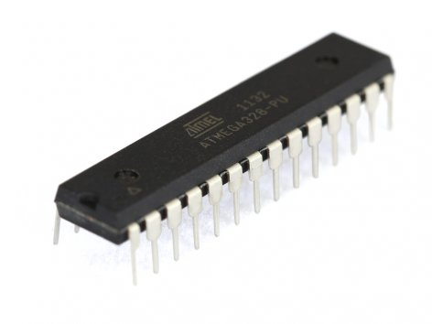**

**Fig 4.3.2 Pin diagram of ATMEGA328P**

**4.4 PROGRAM :**

#include <Wire.h>

#include "RTClib.h"

#define dly 100

RTC\_DS1307 rtc;

#define segA 8

#define segB 9

#define segC 10

#define segD 11

#define segE 12

#define segF 13

#define segG A0

#define e1 2

#define e2 3

#define e3 4

#define e4 5

#define e5 6

#define e6 7

#define leds A1 //led dots

int rep=0,x=0;

//===============================================

//a,b,c,d,e,f,g,dp//

const char char\_byte[][8]={{1,1,1,1,1,1,0,0}, //0

{0,1,1,0,0,0,0,0}, //1

{1,1,0,1,1,0,1,0}, //2

{1,1,1,1,0,0,1,0}, //3

{0,1,1,0,0,1,1,0}, //4

{1,0,1,1,0,1,1,0}, //5

{1,0,1,1,1,1,1,0}, //6

{1,1,1,0,0,0,0,0}, //7

{1,1,1,1,1,1,1,0}, //8

{1,1,1,1,0,1,1,0}};//9

void feed\_disp(unsigned char);

char daysOfTheWeek[7][12] = {"Sunday","Monday","Tuesday","Wednesday","Thursday","Friday","Saturday"};

unsigned long time\_current=0,time\_previous=0;

String serialTime="",serialDate="";

unsigned int t\_year=0,temp=0;

unsigned char t\_month=0,t\_date=0,t\_hour=0,t\_min=0,t\_sec=0;

//-----------------------------------------------------------------------------------------------------

void setup ()

{

pinMode(segA,OUTPUT);

pinMode(segB,OUTPUT);

pinMode(segC,OUTPUT);

pinMode(segD,OUTPUT);

pinMode(segE,OUTPUT);

pinMode(segF,OUTPUT);

pinMode(segG,OUTPUT);

pinMode(e1,OUTPUT);

pinMode(e2,OUTPUT);

pinMode(e3,OUTPUT);

pinMode(e4,OUTPUT);

pinMode(e5,OUTPUT);

pinMode(e6,OUTPUT);

pinMode(leds,OUTPUT);

digitalWrite(segA,HIGH);

digitalWrite(segB,HIGH);

digitalWrite(segC,LOW);

digitalWrite(segD,LOW);

digitalWrite(segE,LOW);

digitalWrite(segF,LOW);

digitalWrite(segG,LOW);

digitalWrite(leds,LOW);

Serial.begin(9600);

Serial.println("Send '#' to set Time and Date");

if (! rtc.begin())

{

Serial.println(F("Couldn't find RTC"));

while (1);

}

else Serial.println(F("RTC Found"));

if (! rtc.isrunning())

{

Serial.println(F("RTC is NOT running!"));

while(1);

}

else Serial.println(F("RTC Running"));

}

//-----------------------------------------------------------------------------------

void loop ()

{

DateTime now = rtc.now();

for(rep=0;rep<1000;rep++)

{

DateTime now = rtc.now();

if(now.second()%2 == 0)

digitalWrite(leds,HIGH);

delay(1);

digitalWrite(e3,LOW);

digitalWrite(e5,LOW);

digitalWrite(e6,LOW);

delay(1);

feed\_disp(now.day()%10);

digitalWrite(e5,HIGH);

digitalWrite(e2,LOW);

digitalWrite(e1,LOW);

digitalWrite(e4,LOW);

digitalWrite(e3,LOW);

digitalWrite(e6,LOW);

delay(1);

feed\_disp(now.day()/10);

digitalWrite(e6,HIGH);

digitalWrite(e2,LOW);

digitalWrite(e1,LOW);

digitalWrite(e4,LOW);

digitalWrite(e5,LOW);

digitalWrite(e3,LOW);

delay(1);

}

for(x=0;x<30;x++)

temp+=analogRead(A2);

temp=temp/x;

temp=temp/2;

digitalWrite(leds,LOW);

for(rep=0;rep<700;rep++)

{

{

Serial.println(F("RTC Time/Date Set Mode:"));

Serial.println(F("Time Format: 24 Hour"));

Serial.print(F("Send Time/Date in this Format "));

Serial.println(F("HH:MM:SS/DD:MM:YY"));

rtc.adjust(DateTime(t\_year, t\_month, t\_date, t\_hour, t\_min, t\_sec));

}

else

Serial.println(F("Wrong Time/Date Format or Values"));

serialTime="";

serialDate="";

}

}

}

//-------------------------------------------------------------

void feed\_disp(unsigned char value)

{

char rep;

for(rep=0;rep<7;rep++)

{

digitalWrite(segA+rep,char\_byte[value][rep]);

}}

**CHAPTER 5**

**RESULT ANALYSIS**

**5.1 Schematic Diagram :**

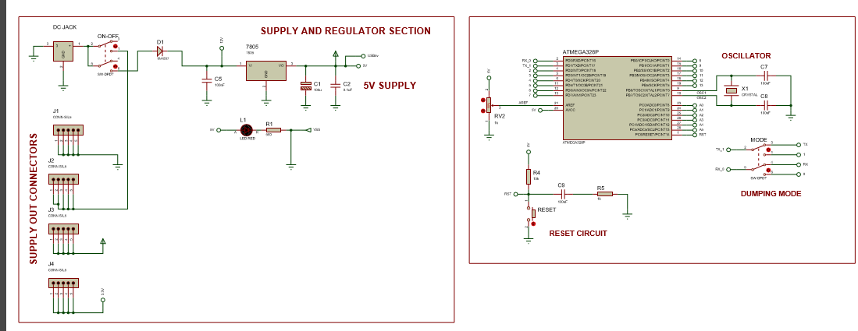

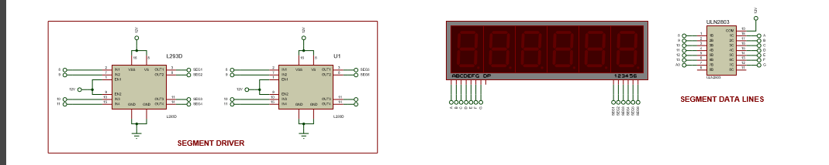

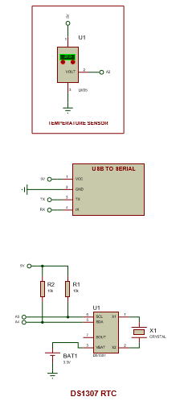

**5.2 ALGORITHM :**

* Define 7 segment display pins.
* Initilize real time clock and assign the pins.
* Assign multiplexing technique.
* Assign serial data & serial time.
* Initialize pin modes for 7 segments.
* Initiate Timer at 1ms interupt.
* Start the process by pushing with the press button.
* Update Date and Time initially.
* Assign high low pins.
* Repeat the process from step 1.

**5.3 SNAPSHOT RESULTS :**

In this real time clock(RTC) we can display date, time and room temperature with the help of seven segment display.

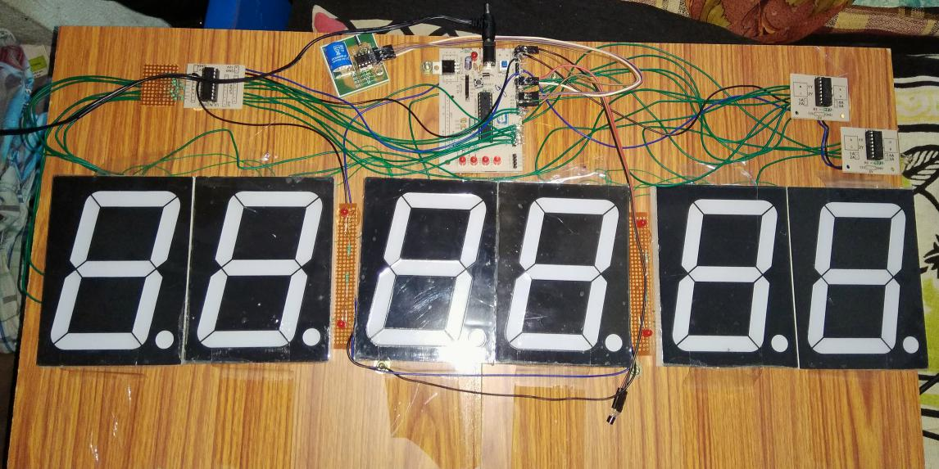

**Fig.no.5.3.1 Seven segment display**

**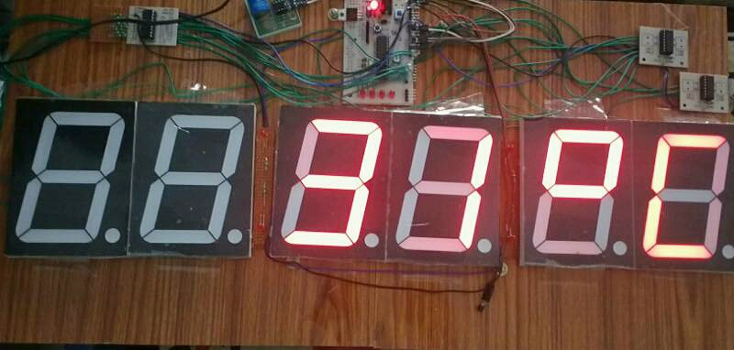**

**Fig.no.5.3.2 Seven segment displaying Temperature**

**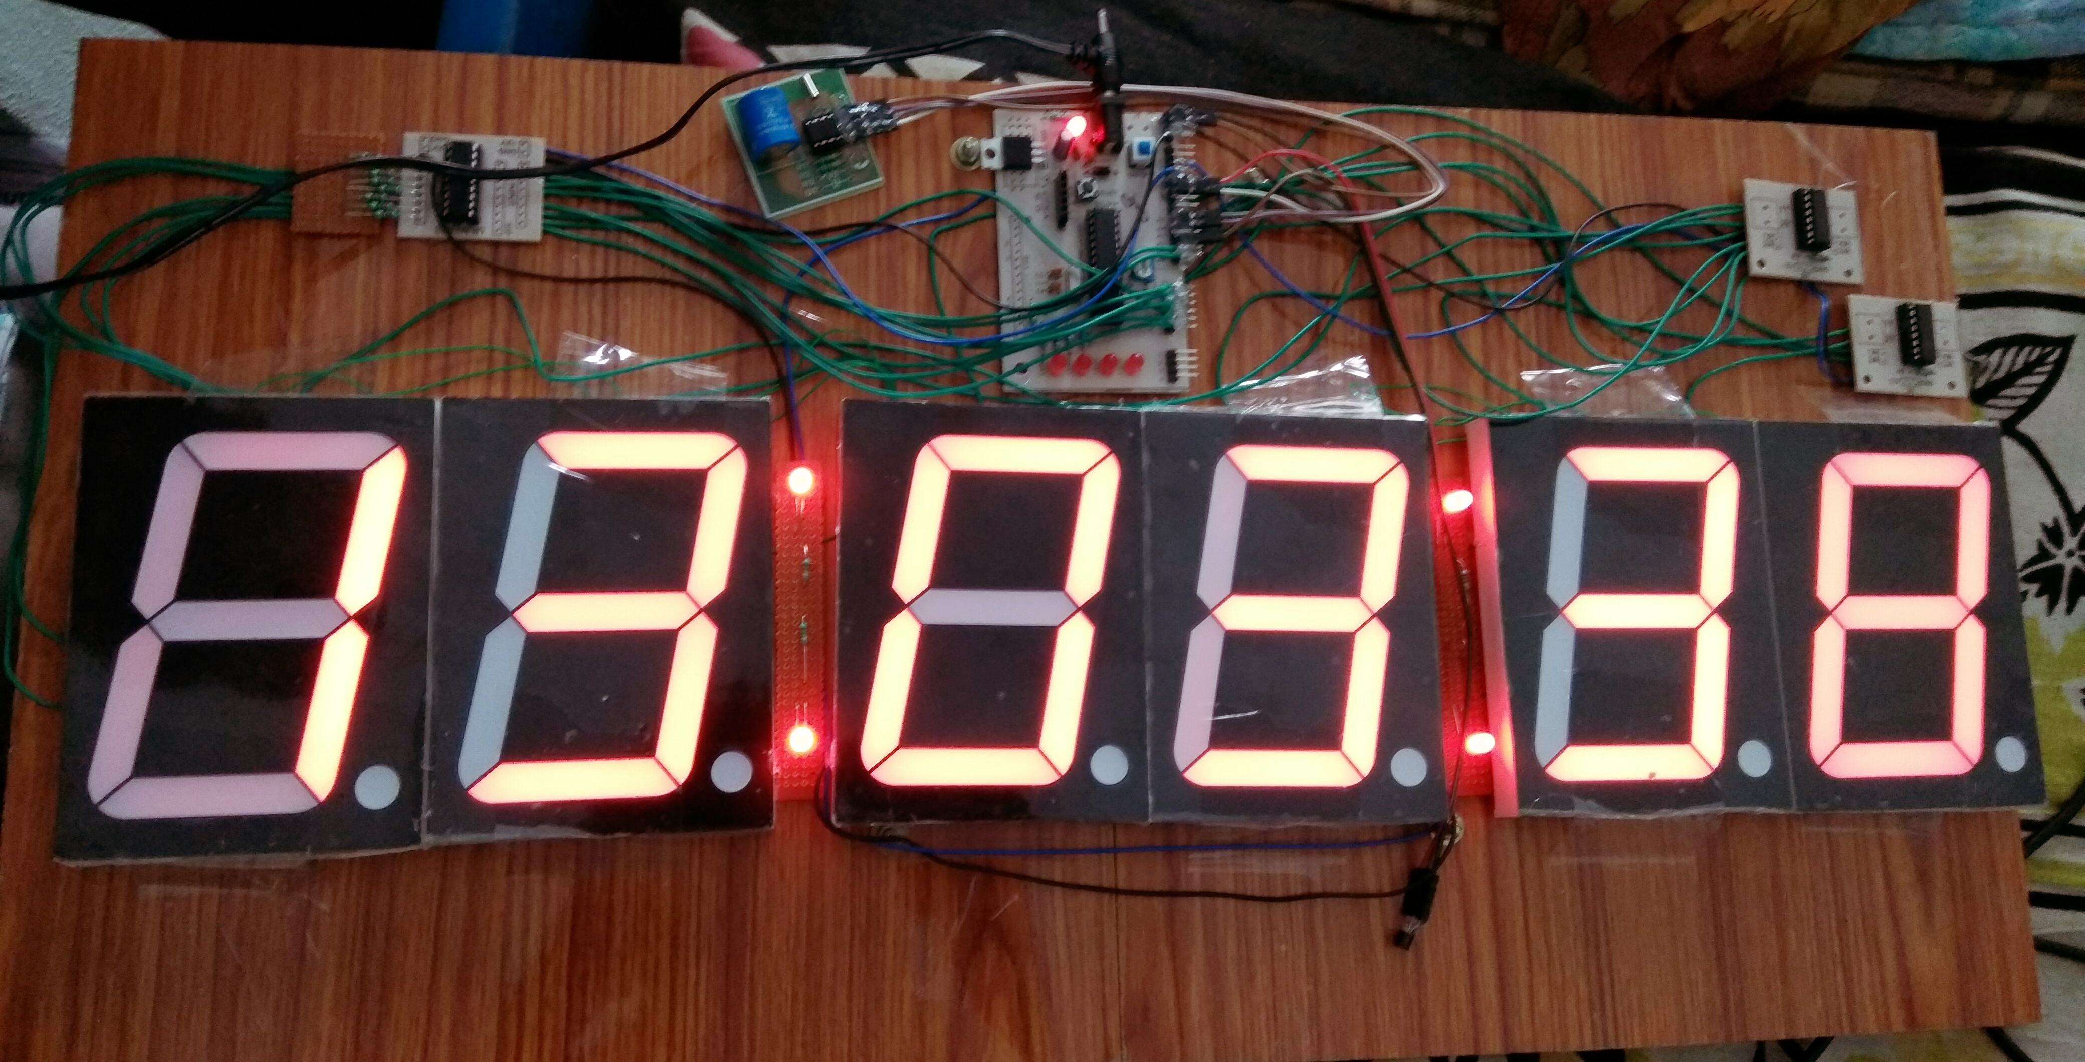**

**Fig.no.5.3.3 Seven segment displaying time in HOURS,MINUTES AND SECONDS**

**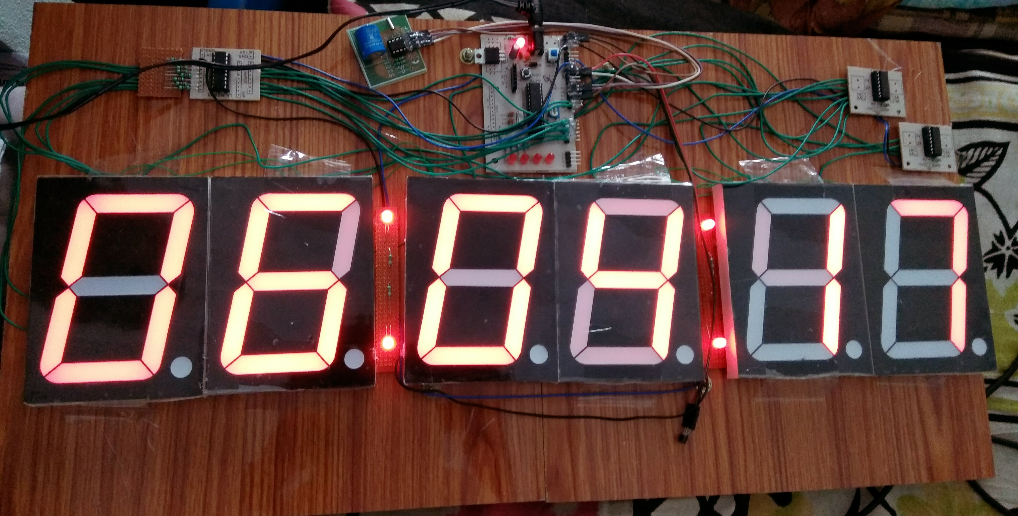**

**Fig.no.5.3.4 Seven segment displaying DATE,MONTH AND YEAR**

**CHAPTER 6**

**CONCLUSION AND FUTURE SCOPE**

**6.1 ADVANTAGES AND DISADVANTAGES**

**ADVANTAGES :**

* Task shifting
* Focus on application
* Error free
* 24-7 systems

**DISADVANTAGES :**

* Maximum Power Consumption
* Low precision of code
* Expensive

**6.2 APPLICATIONS :**

* Smart energy applications
* Temperature sensing applications
* LCD displays
* Ethernet

**6.3 FUTURE SCOPE :**

From this project with the help of 2 pins of micro controller we can connect 127 devices.So that we can display it in more extent.

**CONCLUSION :**

So by this we can conclude that by using multiplexing technique we can control large display segments with the help of small micro controller and we can control these blocks with reduced no.of input outputs.

**APPENDIX**

**REFERENCES**

1. EMBEDDEDSYSTEMSby SHIBU KV.

2. EMBEDDED SYSTEMS by RAJKAMAL.

3. EMBEDDED SYSTEMS by BAKSHI.

4. Wikipedia.

5. Electronics for you.

6. EMBEDDED SYSTEMS by A.P.GODSE &A.O.MULANI.